Advanced Log Analysis Report
Objective
The objective of this exercise was to perform advanced log analysis using simulated security events. The activity focused on log correlation, anomaly detection, and log enrichment techniques commonly used in Security Operations Centers (SOCs) to identify suspicious activity and improve threat visibility.
Tools Used
- Elastic Security
- Security Onion
- Google Sheets / Excel
Log Correlation
Log correlation was performed by analyzing authentication logs, firewall logs, and network connection logs. Multiple failed login attempts (Event ID 4625) originating from IP address 192.168.1.100 were observed. These events were correlated with subsequent outbound network connections to external IP addresses.
The correlation process revealed a sequence of failed authentication attempts followed by suspicious outbound traffic, indicating a potential compromise attempt or unauthorized activity.
Findings
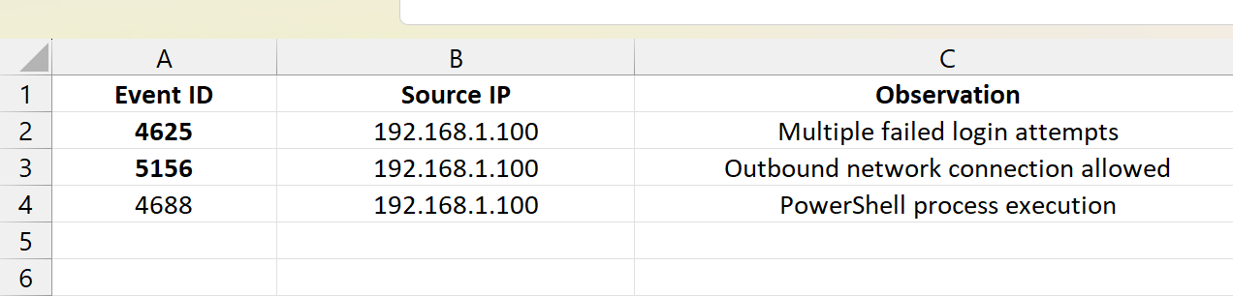
The combined events suggested suspicious activity that warranted further investigation.
Anomaly Detection
An anomaly detection rule was configured to identify unusually high outbound network traffic. The rule generated an alert when outbound traffic exceeded 1 MB within a one-minute period.
A simulated file transfer triggered the detection rule, generating an alert for review. The observed traffic volume significantly exceeded normal baseline activity for the host.
Findings
- High-volume outbound traffic detected.
- Alert generated successfully.
- Potential data exfiltration behavior identified.
- Event escalated for investigation.
Log Enrichment
GeoIP enrichment was applied to destination IP addresses to provide additional contextual information. This process added geographic data such as country and region information to network events.
The destination IP address 104.26.10.78 was enriched with location details indicating communication with an external host located outside the internal network.
Benefits of Enrichment
- Improved analyst visibility.
- Faster investigation process.
- Better identification of unusual geographic connections.
- Enhanced threat-hunting capability.
Results
The exercise successfully demonstrated the use of advanced log analysis techniques for detecting suspicious activity. Log correlation enabled the identification of related security events across multiple data sources. Anomaly detection highlighted abnormal network behavior, while log enrichment provided additional context for investigation.
The combination of these techniques improved threat visibility and reduced the likelihood of missing important indicators of compromise.
Conclusion
Advanced log analysis is a critical SOC function that supports effective threat detection and incident response. Through log correlation, anomaly detection, and enrichment, analysts can identify suspicious patterns more efficiently and make informed decisions during investigations. The exercise successfully met all objectives and demonstrated practical SOC monitoring workflows.

